Security Analysis Report for Cyclomatic Cyclops

Security Score

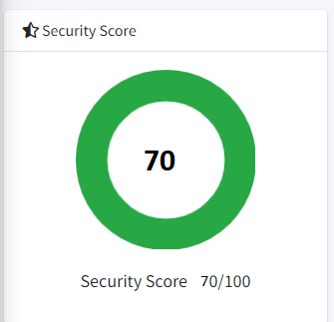

Risk Rating

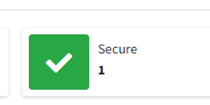

Findings

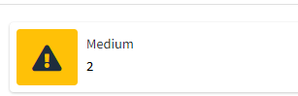

NO ISSUE SEVERITY STANDARDS FILES

1 The App logs information. Sensitive

information should never be logged.

CWE: CWE-532

OWASP MASVS:

MSTG- STORAGE

**Endpoint:-**

TrackerForMakeathon/TrackerForMakeathon/AppDelegate.swift

TrackerForMakeathon/TrackerForMakeathon/ViewControllers/Dashboard.swift

TrackerForMakeathon/TrackerForMakeathon/ViewControllers/Vie

controller.swift

Why Secure?

This application does not include any user or device trackers. Unable to find trackers during security analysis.

Risk:

Outdated Cryptography.

Weak encryptions might result in the exposure of sensitive data through potential vulnerabilities. And this is known as cryptographic failures

Mitigation:

Enforce encryption using directives like HTTP Strict Transport Security (HSTS). Disable caching for responsess that contains sensitive data. Apply required security controls as per the data classification. Do not use legacy protocols such as FTP and SMTP for transporting sensitive data.